

MotorPH


Business Analysis

Report

Prepared and Presented by:

Kayel Niccolo C. Astrera
Bachelor of Science in Information Technology
Term 1 Academic Year 2026-2027

Intellectual Property Notice

This template is an exclusive property of Mapua-Malayan Digital College and is protected under Republic Act No. 8293, also known as the Intellectual Property Code of the Philippines (IP Code). It is provided solely for educational purposes within this course. Students may use this template to complete their tasks but may not modify, distribute, sell, upload, or claim ownership of the template itself. Such actions constitute copyright infringement under Sections 172, 177, and 216 of the IP Code and may result in legal consequences. Unauthorized use beyond this course may result in legal or academic consequences.

Additionally, students must comply with the Mapua-Malayan Digital College Student Handbook, particularly with the following provisions:
- Offenses Related to MMDC IT:
  - Section 6.2 – Unauthorized copying of files
  - Section 6.8 – Extraction of protected, copyrighted, and/or confidential information by electronic means using MMDC IT infrastructure
- Offenses Related to MMDC Admin, IT, and Operations:
  - Section 4.5 – Unauthorized collection or extraction of money, checks, or other instruments of monetary equivalent in connection with matters pertaining to MMDC
Violations of these policies may result in disciplinary actions ranging from suspension to dismissal, in accordance with the Student Handbook.

For permissions or inquiries, please contact MMDC-ISD at isd@mmdc.mcl.edu.ph.

<IMPORTANT NOTE: Modify the page numbers of the items in the table of contents based on the order in the final version of your output. Delete this note before submission>

- Executive Summary
Background. MotorPH is a motorcycle retailer. This report analyzes its product catalogue (50 models in 17 categories) and 994 sales orders recorded from June to August 2025 to find out how sales are performing and what the business should do next.
Scope and limitations. The sales data cover 1 June to 31 August 2025 (plus one order dated 13 January 2025). There are no September records, so the Q3 comparison uses July and August. The files have no stock quantities or unit costs, so the report describes sales, not stock levels or profit.
Key findings. The catalogue's mean unit price is ₱257,872 (range ₱48,000 to ₱995,000). The 994 orders brought in ₱4.46B from 17,619 units. Monthly revenue fell from ₱1.52B in June to ₱1.49B in July (-2.1%) and ₱1.45B in August (-3.0%), driven by fewer orders (342, 331, 320) rather than smaller ones. Scooter, Cruiser and Naked Bike earn 44% of revenue. Heritage earns ₱276.6M per model, 3.1 times the average. Normality tests rejected a normal distribution for every sample. Mann-Whitney U tests found no significant difference between July and August in order value (p = 0.654) or units per order (p = 0.738). Price and units sold across the 50 models are unrelated (rho = -0.073, p = 0.613).
Main conclusions. Customer behaviour per order was stable from July to August, and price does not appear to limit volume. The revenue decline reflects order count, which these tests could not assess.
Business implications and recommendations. Keep high-yield categories (Heritage, Cruiser) fully available and promoted. Review the 12-model scooter line, where three models overlap at about ₱80,000. Check margin and stock before delisting low earners. Put effort into winning more orders rather than cutting prices. Collect stock, cost and monthly channel data, and repeat the analysis with more months.

- Introduction
- Purpose of the report. This report brings together the three stages of the MO-IT106 analysis of MotorPH: the product inventory report (Milestone 1), the sales dashboard (Milestone 2) and the inferential analysis. It answers three questions. What does MotorPH sell? How are those products selling? Did sales change between July and August 2025?
- Overview of MotorPH's data. The product dataset has one row for each of 50 models, with product type, unit price, year manufactured (2020 to 2023) and year acquired (2021 to 2024). The sales dataset has 994 orders from June to August 2025 (plus one order dated 13 January 2025), with date, client type (retail or wholesale), product, unit price, quantity, total and payment method. Every sale matches a catalogue product and every total equals unit price times quantity.
- How the report supports decision-making. The findings show which categories and models earn the most, how sales moved from month to month, and whether the July to August change is statistically meaningful. They also show what the data cannot yet answer, such as stock levels and profit, so that MotorPH knows what to measure next.

- Methodology
The work followed one sequence: load the two CSV files, validate and clean them, compute summary tables, draw the charts, then run the statistical tests. Each step is done in the two Python scripts, MotorPH_Final_Dashboard.py and MotorPH_Inferential_Analysis.py.

A. Scope
- Datasets used. MotorPH_Products_Preprocessed.csv (50 products, 6 columns) and MotorPH_Sales_Preprocessed.csv (994 orders, 7 columns).
- Timeframe covered. Sales from 1 June to 31 August 2025, plus one order dated 13 January 2025. There are no records for February to May or for September, so the Q3 2025 comparison uses July and August, with June as a reference month.
- Key variables. Products: product type, unit price, year manufactured, year acquired. Sales: date, client type, product, unit price, quantity, total, payment method.
- Types of analysis. Descriptive analysis, visualization and inferential analysis (normality testing, hypothesis testing and correlation).

B. Data Preparation
- Data sources. The two MotorPH datasets above. The raw sales file (MotorPH_Sales_Data-3rd_Quarter-Year_2025_1.csv) had 1,000 rows.
- Handling missing values. Two rows had no date and four had impossible dates (2025/07/32 twice, 2025-08-00 and 08-40-2025). These six rows could not be recovered and were removed, leaving 994 rows. Ten blank client types and ten blank payment methods were labelled "Unknown" and kept, because the sales are real (0.8% and 0.7% of revenue).
- Removing duplicates. The scripts check for duplicate sales rows and duplicate product IDs and names. They found none (0 removed).
- Correcting data types. Dates are converted to datetime. Unit price, quantity and total are converted to numbers. Mixed date formats (07-25-25, Aug-10-2025, 13/01/2025) were standardized to one format.
- Standardizing formats. Column headers were renamed (for example "unitprice" became "Unit Price"), text was trimmed and capitalization made consistent ("Credit card" became "Credit Card"), and 15 truncated product names (for example "Benelli 502x") and incorrect unit prices were corrected so that all totals equal unit price times quantity.
- Validation after cleaning. Both scripts re-check the data: 0 rows removed, 0 totals corrected, 0 duplicates, 0 sales not matched to a catalogue product and 0 sales priced differently from the catalogue. Each sale is joined to the catalogue by Product Name to get its Product Type.

C. Data Analysis Process
- Descriptive analysis (Milestone 1). Number of products, distribution by product type, price statistics (mean, minimum, maximum) and total catalogue value.
- Sales trend and comparison analysis (Milestone 2). Revenue, units and orders by month and by week, client type, payment method, product and category. Revenue per model compares categories of different sizes. A dashboard (PNG and PDF) and a formula-driven Excel dashboard present the results.
- Inferential analysis. Significance level 0.05 for every test.
  - Normality testing. Histograms with a fitted normal curve and Q-Q plots, plus the Shapiro-Wilk test (main) and D'Agostino-Pearson test (cross-check), for order value and units per order in July and in August.
  - Hypothesis testing. Because normality was rejected, the Mann-Whitney U test compares July and August (main test). The Welch t-test and Levene's test are cross-checks. A Spearman correlation tests unit price against units sold across the 50 products.
Tools used. Python (pandas, NumPy, Matplotlib,), and Microsoft Excel for the dashboard workbook.

- Data Analysis and Interpretation
  - Descriptive Analysis
Distribution of product types. Scooter is the largest type with 12 products (24%), followed by Naked Bike with 7 (14%). Sport, Adventure and Cruiser have 4 each (8%), Underbone and Dual-Sport have 3 each (6%), and Cafe Racer, Commuter and Heritage have 2 each (4%). Seven types have a single model (2% each): Classic, Retro, Sport Touring, Scrambler, Standard, Touring and Street. These counts are product records, not stock quantities.
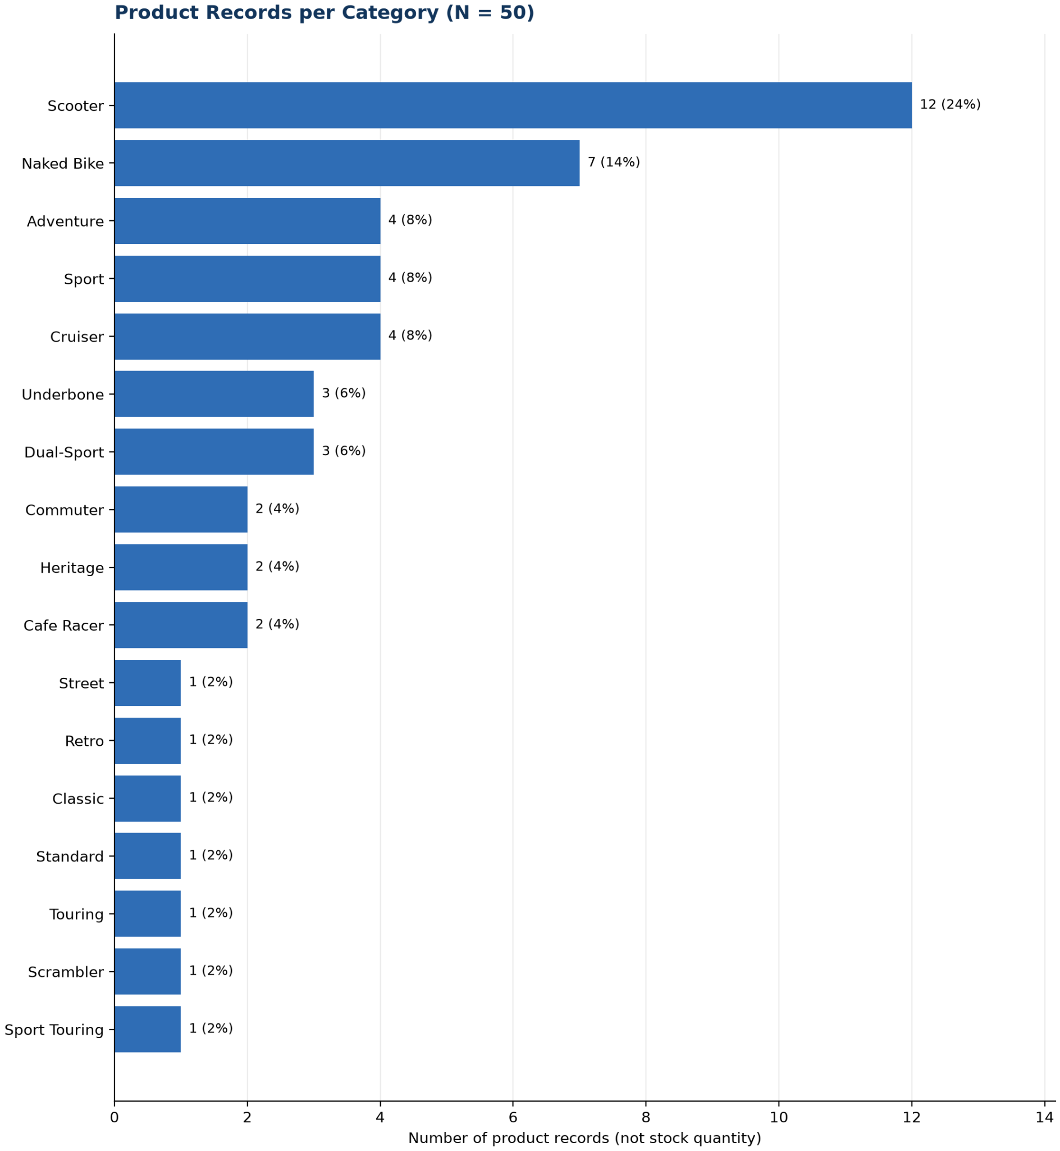

- Total number of products: 50
- Distribution of product types:17
- Price statistics. Mean unit price is ₱257,872. The cheapest model is the Rusi Flash 125 at ₱48,000 and the most expensive is the BMW R nineT at ₱995,000, a range of ₱947,000.
- Total inventory cost. Adding up the unit price of every product gives ₱12,893,600. This is the template's "total inventory cost" figure. It is the price of one unit of each model, not the value of stock on hand, because the data contain no stock quantities.
- Age of the range. Models were manufactured from 2020 to 2023 (5, 8, 16 and 21 models in 2020, 2021, 2022 and 2023) and acquired from 2021 to 2024 (5, 7, 17 and 21 models in 2021 to 2024). Most of the range is recent: 37 of 50 models were manufactured in 2022 or 2023.
- Interpretation. MotorPH offers a wide spread of segments and prices, from entry-level commuters to premium heritage bikes. Scooters dominate the catalogue by count. Section IV.B shows whether that count matches sales.

  - Sales Analysis
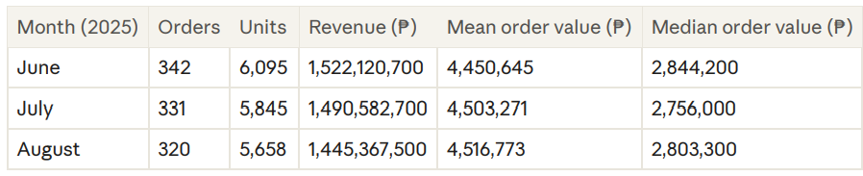
Overall. The 994 orders brought in ₱4,459,496,800 from 17,619 units: ₱4,486,415 per order and 17.7 units per order. Retail contributed 53.5% of revenue (518 orders), wholesale 45.7% (466 orders) and orders with an unknown client type 0.8% (10 orders). Credit card accounted for 35.2%, bank transfer 32.1%, cash 32.0% and unknown payment method 0.7%.

- Monthly sales trends
- One order dated 13 January 2025 (₱1,425,900, 21 units) is the only record outside June to August. Comparisons between months. Revenue fell 2.1% from June to July and 3.0% from July to August, 5.0% over the two steps. Orders fell by 3.2% and then 3.3%, units by 4.1% and then 3.2%. Mean order value rose by 1.2% and 0.3%. The fall is therefore a fall in the number of orders. Median order value was about ₱2.8M in each month. Weekly pattern. Across the 13 full weeks from 2 June to 31 August, weekly revenue averaged ₱338.9M. The lowest week ended 24 August (₱260.0M) and the highest ended 31 August (₱452.4M). The next highest week ended 3 August (₱451.5M).
- Notable patterns and anomalies. Heritage earns three times the average revenue per model (₱89.2M) from 2 models, while Scooter, with the most models, earns less than average. Commuter, Standard and Underbone earn the least per model. The two highestearning weeks both contain a month-end. The sales file has no records for February to May or September, which limits any conclusion about longer trends. Interpretation. Sales are spread across many categories but earned unevenly. Number of models is a poor guide to revenue. Order value is steady, so MotorPH's revenue moves with how many orders it wins

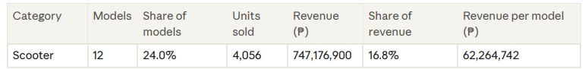
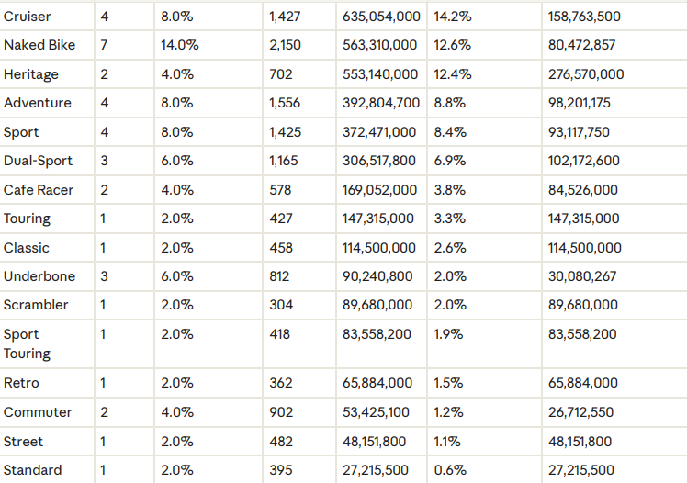

  - Inferential Analysis
The question is whether MotorPH sales changed between July (331 orders) and August 2025 (320 orders). All tests use a 0.05 significance level. A p-value below 0.05 means reject H0.
- Hypothesis:
  - H0: the variable is normally distributed.
  - H1: it is not
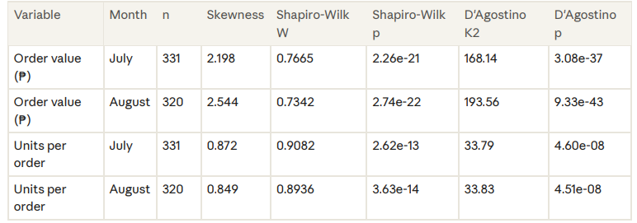
- Test 1. Normality of July and August order values and units
- Decision. Reject H0 in all four cases. Interpretation. Order values and units per order are not normally distributed. Order value is strongly right-skewed: many small orders and a few very large ones (the histograms and Q-Q plots in Appendix VI show this). A t-test is therefore not the right main test, so the Mann-Whitney U test is used.

Test 2. July versus August order value (₱) Hypothesis. H0: July and August order values come from the same distribution. H1: they differ. Test used. Mann-Whitney U, two-sided (main). Welch t-test and Levene's test as crosschecks. Results
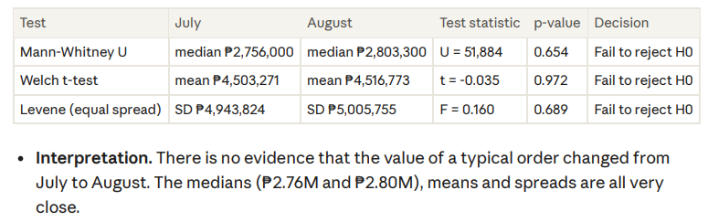
Test 3. July versus August units per order Hypothesis. H0: July and August units per order come from the same distribution. H1: they differ. Test used. Mann-Whitney U, two-sided (main). Welch t-test and Levene's test as crosschecks. Results
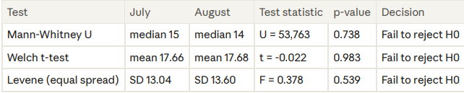
Interpretation. Customers bought about the same number of units per order in both months (about 17.7 on average). The one-unit difference in medians (15 vs 14) is within chance variation.

Test 4. Unit price and units sold across the 50 products Hypothesis. H0: there is no monotonic relationship between unit price and total units sold (rho = 0). H1: there is one (rho is not 0). Test used. Spearman rank correlation. Results. rho = -0.073, p = 0.613, n = 50 products. Decision. Fail to reject H0. Interpretation. Across the catalogue, more expensive models do not sell noticeably fewer or more units than cheaper ones. Price is not what separates fast sellers from slow ones in this data. What the tests mean for MotorPH. Failing to reject H0 means the data give no evidence of a change. It does not prove that July and August are the same. These tests compare individual orders. They do not test whether the number of orders or the monthly total changed, so the 3.0% fall in August revenue shown in Section IV.B is a description, not a tested trend.

- Conclusions and Business Insights
MotorPH sells a broad range across 17 categories, and its revenue comes from a few categories and high-priced models rather than from the models that are most numerous. Per-order behaviour was steady from July to August, while the number of orders slipped each months.

  - Observation and Findings
Patterns across product and sales data.

- Revenue fell from ₱1.52B (June) to ₱1.49B (July) to ₱1.45B (August), because orders fell from 342 to 331 to 320 while mean order value stayed near ₱4.5M.

- Retail (53.5%) and wholesale (45.7%) are balanced, and payment methods are evenly split (35.2%, 32.1%, 32.0%).

- Scooter, Cruiser and Naked Bike earn 44% of revenue. The top 10 products earn 42.3%.

- Heritage (2 models) earns ₱276.6M per model against an average of ₱89.2M. Scooter (12 models) earns ₱62.3M per model.

Key data-driven insights. Price does not limit volume (Spearman rho = -0.073, p = 0.613). The ten best-earning models average ₱508,200 per unit, about twice the catalogue average, so premium models carry revenue. July and August orders are statistically alike in value (Mann-Whitney p = 0.654) and size (p = 0.738), so the August dip is not a change in order behaviour. Several low-priced models sell well in units but earn little (Bajaj CT125: 509 units, ₱34.6M). SYM Husky 150 earns the least of all 50 models (₱13.9M). Summary of important findings. Revenue is concentrated, catalogue size does not predict revenue, price does not predict units sold, and the August decline is a matter of fewer orders. The data cannot show stock levels, margins, or any pattern beyond June to August 2025.

  - Predictive Analytics and Recommendations
Expected trends or outcomes. Revenue has fallen by an average of ₱38.4M a month since June. If that continues, September revenue would be about ₱1.41B (-2.7% against August). IfAugust's level holds, it would be about ₱1.45B. These are simple three-month projections and should be treated as a range, not a forecast.
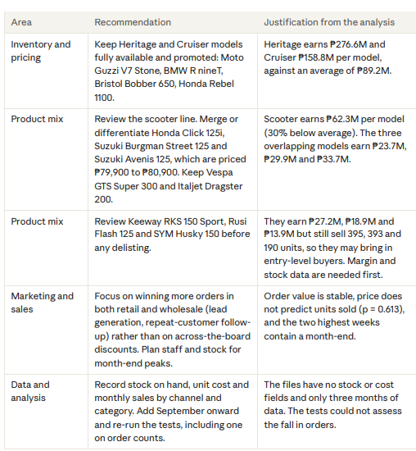

- Justification. Each recommendation rests on a figure computed from MotorPH's own data. None of them should be applied to purchasing or delisting before margin and stock data are checked.

- Appendices
Provide links to all datasets used in the analysis. Ensure access permissions are properly set.

Component | Instructions
Dataset(s) | MotorPH_Products_Preprocessed.csv (50 products, 6 columns): https://drive.google.com/file/d/1iskugZ_nPpVCSC6OyViqG73nHnVMumo4/view?usp=drive_link  | MotorPH_Sales_Preprocessed.csv (994 orders, 7 columns):https://drive.google.com/file/d/1Ju5YXJ1NydLMuL4_h3aH74MZwS1DvWEd/view?usp=drive_link | Source file:  GitHub repository: https://github.com/lrknastrera-gif/MO-IT106-Astrera-K-DAF
Python Code | - MO-IT106 Terminal Assessment DAF  All the codes are in this folder.
Supporting Outputs (Optional) | MotorPH_Dashboard.xlsx  MotorPH_Dashboard.png

